HONPA HONGWANJI HAWAII BETSUIN
Buddhist Education Committee
2014 AUTUMN OHIGAN – PEACE WEEK
A “TALK STORY” WITH REVEREND WILL MASUDA
SHIN BUDDHIST PERSPECTIVES ON PEACE: HOW TO EXPRESS PEACE

About “Talk Story”
“Talk Story” is an important local cultural experience in which people share their life experiences. At Hawaii Betsuin during Ohigan, we invite special Dharma teachers to lead conversations that further our understanding and experience of the Nembutsu Way within a “talk story” setting. These sessions are open to everyone.
Shin Buddhism and Peace by Reverend William Masuda
The heart of our Shin Buddhist life is awakened in the moment we receive and entrust our life to the workings of Amida Buddha’s Primal Vow of great Wisdom and Compassion. We are then empowered to respond to the many forms of human suffering we encounter with a clear, mindful attitude and a caring, heart-centered action. As Shin Buddhists we will explore the ways in which we can address and resolve this issue of peace in our personal life as we contribute to the peace and harmony of life around us in our society and in the world.
About the Dharma Teacher
Reverend William Masuda is a long-time Dharma friend of the Hawaii Sangha. He served our Kyodan as Director of Buddhist Education and Director of the Buddhist Study Center (BSC) from 1976 to 1983. His educational background include B.A., Psychology, California State University, San Francisco, 1962; M.A., Jodo Shinshu Buddhist Studies, Ryukoku University, 1965; Ed.D., Counseling Psychology, School of Education, University of San Francisco, 1993.  Reverend Masuda’s ministerial career with the Buddhist Church of America (BCA) include serving as resident minister at four California temples. His last assignment was with the Palo Alto Buddhist Temple. He is currently a member, Stanford Hospital Clinical Pastoral Education Advisory Committee; a Resource Chaplain, Spiritual Care Service, Stanford Hospital; and member, Peninsula Clergy Network, Interfaith Ministers’ Association. In addition to holding academic teaching positions, he practiced psychotherapy and counseling in Berkeley, San Rafael, and San Jose (1987-1996).  Reverend Masuda and his wife, Kiyo, reside in Oakland, California; and they have two sons and a daughter (deceased). | 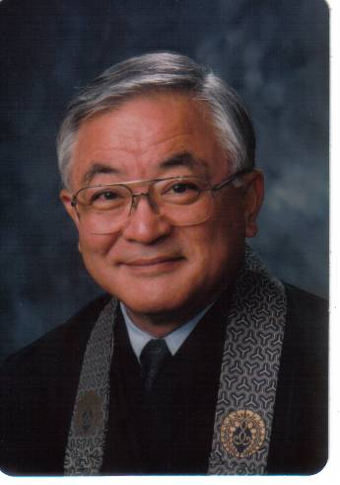

Saturday, September 20, 2014
8:30 am to 12:00 pm
Honpa Hongwanji Hawaii Betsuin – Annex Temple
Registration Fee: $10.00 per participant without lunch or $15.00 with lunch
Make checks payable to Honpa Hongwanji Hawaii Betsuin
Registration Deadline: September 10, 2014
------------------------------------------------------------------------------------------------------------------------------------------------------------------
Registration Form
Name |  | Email Address | Phone #
Temple Affiliation | Please indicate (X) :  Without Lunch ($10) ____ With Lunch ($15)______ |  | Registration Payment  $____________________________

