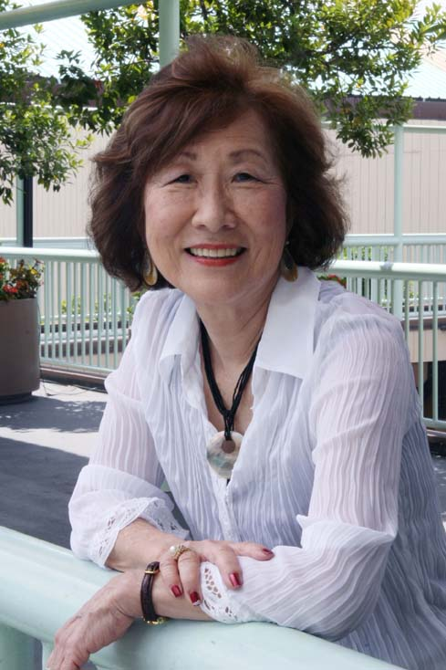 | Presentation by Frances Kakugawa  Poet, Author, Lecturer  Dignity, Joy and Compassion in Giving Care  “Caring for our elders with compassion and dignity and how caregiving is a gift and a legacy of human kindness for our younger generations.” Frances Kakugawa  Sunday, November 8, 2015  11:00 to 11:30 am Registration and Refreshments  Hawaii Betsuin Social Hall  11:30 am to 1:00 pm  Honpa Hongwanji Hawaii Betsuin -- Annex Temple  1727 Pali Highway, Honolulu, HI 96813  Event is free and open to the public.  Contact Hawaii Betsuin Office for information -- 536-7044

About the Lecturer
Frances Kakugawa, who currently resides in Sacramento, was born and raised on the Big Island of Hawaii in Kapoho, which was demolished by lava when she was 18 years old. She has taught for many years in the Michigan and Hawaii public school systems; conducted language arts workshops for teachers in Micronesia and in Hawaii; and was a curriculum writer and lecturer for the University of Hawaii.
In 2002, she was recognized in the Living Legacy: Outstanding Women of the 20th Century in Hawaii book. In 2004 she was the deserved recipient of the Hawaii Publishers Association award for excellence in children's books for bringing her character Wordsworth to life in Wordsworth the Poet. Among her other accolades:
• Northern California Publishers & Authors - Best Illustrated Children’s Book; Mom’s Choice Award: Wordsworth Dances the Waltz
• Northern California Publishers & Authors - Best Non-Fiction: Kapoho: Memoir of a Modern Pompeii
• Hawaii Pacific Gerontological Society: Communications/Arts Category Award for work with the elderly
• California Writers’ Club - Award-winning short stories Haole Style, One Time ‘nuff and You’re Going to Hell
Today, she continues to write, conducts writing support groups for caregivers, gives writing workshops for adults and children, and gives lectures on care giving and writing throughout the U.S.
NOTE: Ms. Kakugawa will be the keynote speaker for the JOURNEYS TO WELLNESS IV on Saturday, October 31, 2015 (8:00 am to 3:00 pm) sponsored by the Sunrise Ministry Foundation – Community Church of Honolulu. Topic: “The Healing Power of Voice and Silence”. Bishop Eric Matsumoto and Rev Bert Sumikawa are participating in this event.

